* 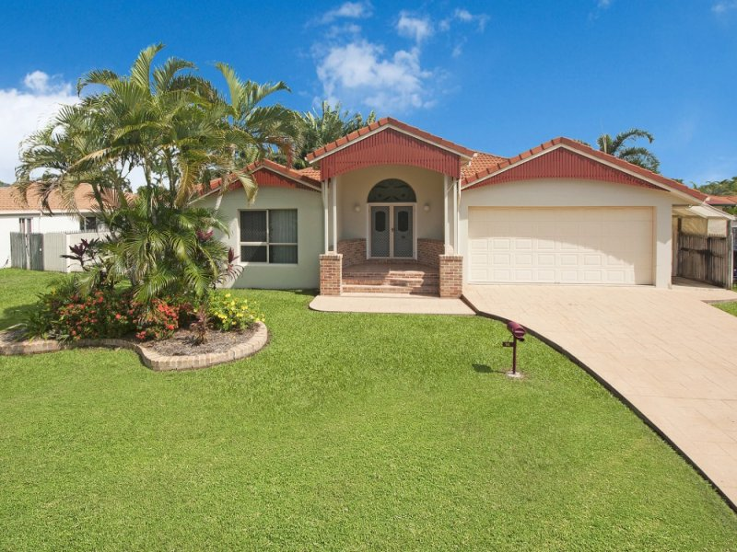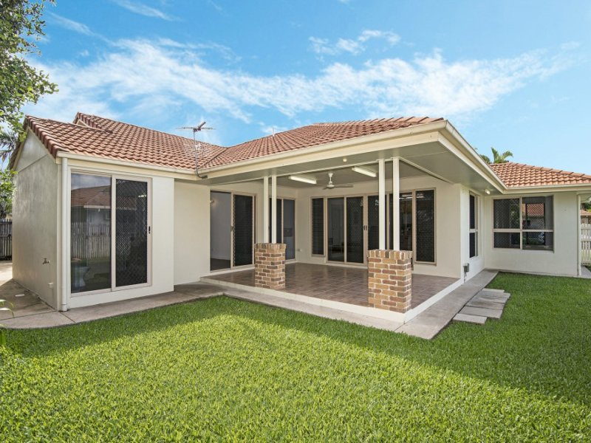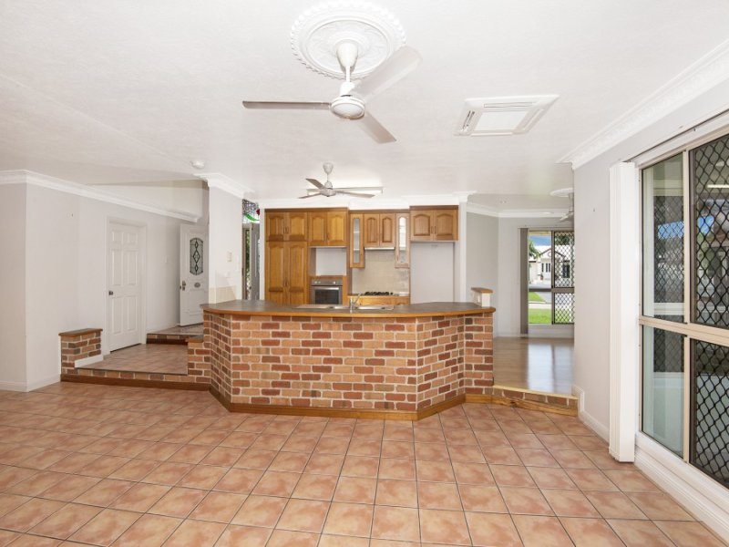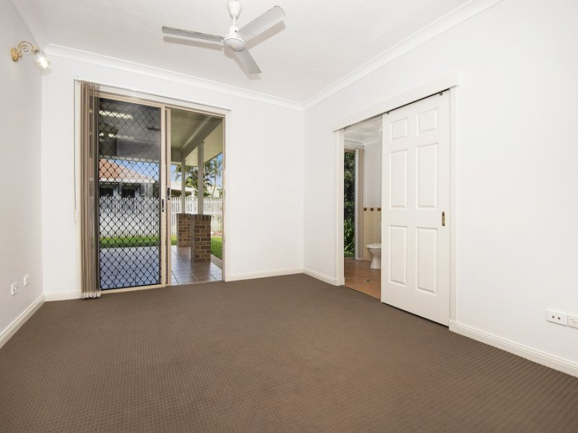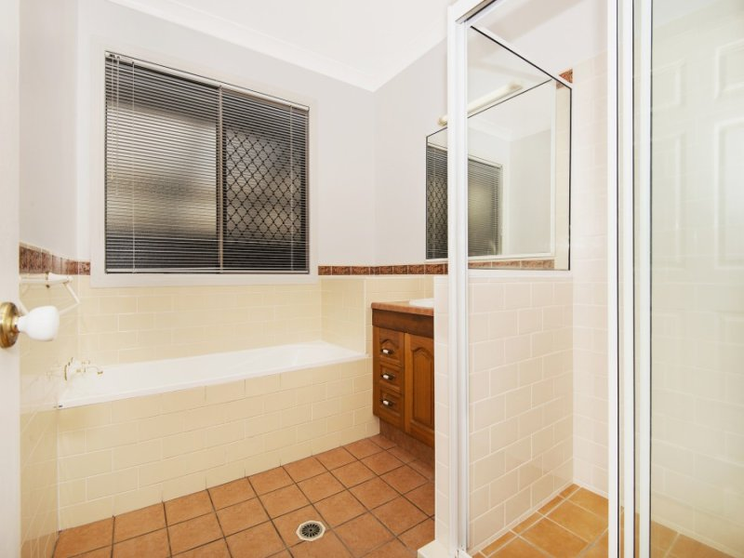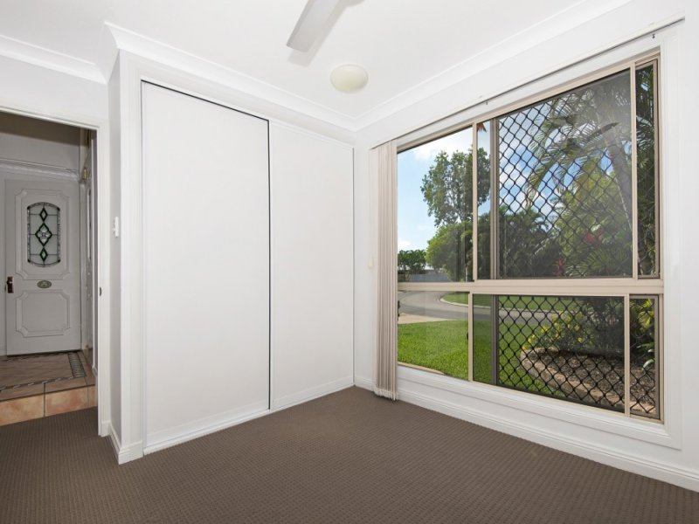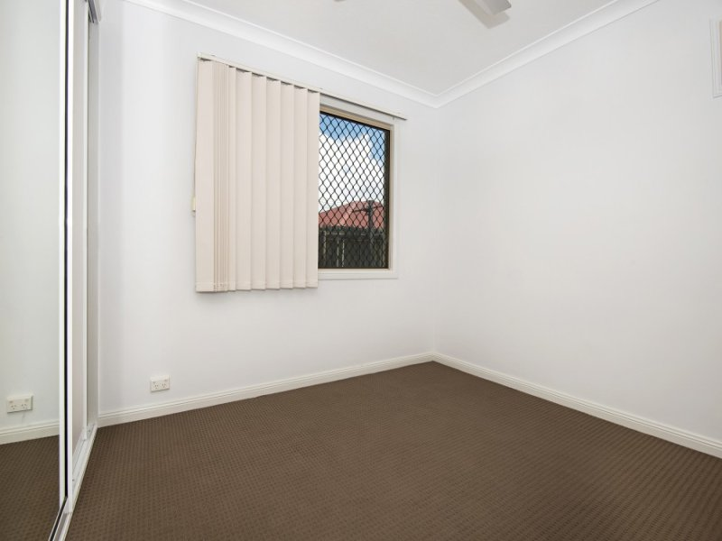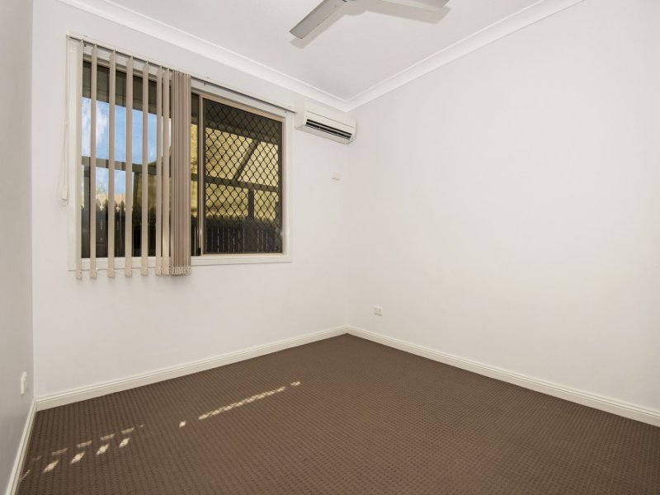$395 Weekly

- Unique Open Plan Living for Dinner Parties  
- Fully Tiled throughout with Carpet in the Bedrooms  
- Cook up a storm in your Quality Gourmet Kitchen  
- Air-conditioned throughout (Great for the Summer Months)  
- Undercover Patio for Entertaining with Family and Friends  
- Spacious Fully Fenced Backyard for the kids to kick the Football  
- Shop until you drop at Willows Shopping Centre, Cheers on the Cowboys at 1300 Smiles Stadium or dip your toes in The Ross River.